**UFS**

**Business Requirements Definition**

**Audit report Phase 2 to have additional field for customer or contract level changes**

Document History

|  |  |  |  |
| --- | --- | --- | --- |
| Date | Version | Author | Section(s) Amended |
| 05/09/2024 | 0.1 | Yasar Galiyara | Drafted the requirements |
| 12/09/2024 | 0.1 | Shaveena | Reviewed |
| 13/09/2024 | 0.2 | Yasar | Added additional requirments |
|  |  |  |  |

Document Sign Off

|  |  |  |  |
| --- | --- | --- | --- |
| Date | Version | Name | Company / Position |
|  |  |  |  |
|  |  |  |  |
|  |  |  |  |
|  |  |  |  |

BSDD Reference (if applicable)

|  |  |  |
| --- | --- | --- |
| Name | Version | Date |
|  |  |  |

Table of Contents

1 Purpose 4

2 Glossary 4

3 Overview / Scope of Functional Requirements 4

3.1 Requirements Overview 4

3.1.1 In Scope 4

3.1.2 Out of Scope 5

3.2 Summary of Requirements 5

3.3 Assumptions 5

4 Detailed Description of Functional Requirements 6

4.1 Requirement BRD01-01 6

4.1.1 Existing Customer Audit report to have below additional field in the report. 6

4.2 Requirement BRD01-02 6

4.2.1 Existing Account Audit report to have below additional fields in the report. 6

4.2.2 Changes to existing fields in Account Audit report. 7

5 Detailed Description of Non-Functional Requirements 8

5.1 Volumes 8

5.2 Performance 8

5.3 Security 8

5.4 Migration 8

5.5 Data Requirements 8

5.6 GDPR 8

5.7 Others (amend heading) 9

6 Use Cases 9

# Purpose

UFS want to additional fields to existing Customer Audit and Account Audit report.

# Glossary

|  |  |
| --- | --- |
| Term | Description |
|  |  |
|  |  |
|  |  |
|  |  |

# Overview / Scope of Functional Requirements

## Requirements Overview

We want to add more fields to existing Customer Audit and Account Audit reports to get more details about the change.

UFS require below additional field in the reports:

* Date of change
* Time of change
* Inputter detail
* Authorizer detail
* Correct account number (should not be the core T24 number)
* Account Title
* Customer ID
* Customer Name

### In Scope

Provide the below additional fields to the Customer Audit report.

1. Date of change
2. Time of change
3. Inputter detail
4. Authorizer detail

Provide the below additional fields to the Account Audit report.

1. Date of change
2. Time of change
3. Inputter detail
4. Authorizer detail
5. Customer ID
6. Customer Name
7. Account Title

Changes to existing fields in Account Audit report.

1. Correct account number (should not be the core T24 number)
2. To show Product description in Product field

### Out of Scope

Any requirement not mentioned in section 3.1.1

## Summary of Requirements

| Requirement Reference | Requirement Title | Summary Description |
| --- | --- | --- |
| BRD01-01 | Customer Audit report | Provide the below details to the Customer Audit report.   1. Date of change 2. Time of change 3. Inputter detail 4. Authorizer detail |
| BRD01-02 | Account Audit report | Provide the below details to the Account Audit report.   1. Date of change 2. Time of change 3. Inputter detail 4. Authorizer detail 5. Customer ID 6. Customer Name 7. Account title   Changes to existing fields in Account Audit report.   1. Correct account number (should not be the core T24 number) 2. To show Product description in Product field |

## Assumptions

N.A

# Detailed Description of Functional Requirements

## Requirement BRD01-01

### Existing Customer Audit report to have below additional field in the report.

1. Date of change: To display the date shown in Audit in below format

Date format: DD/MM/YY

E.g: 18/07/24

1. Time of change

Time format: HH:MM

E.g. 18:30

1. Inputter detail

Value in USER.NAME field to be displayed for inputter detail

1. Authorizer detail

Value in USER.NAME field to be displayed for Authorizer detail

## Requirement BRD01-02

### Existing Account Audit report to have below additional fields in the report.

1. Date of change: To display the date shown in Audit in below format

Date format: DD/MM/YY

E.g.: 18/07/24

1. Time of change

Time format: HH:MM

E.g. 18:30

1. Inputter detail

Value in USER.NAME field to be displayed for inputter detail

E.g. For user UFS.Y.GALIYARA user name is Yasar Galiyara

1. Authorizer detail

Value in USER.NAME field to be displayed for Authorizer detail

E.g. For user UFS.Y.GALIYARA user name is Yasar Galiyara

1. Customer ID

Show customer ID similar to how it’sshown in Customer Audit report.

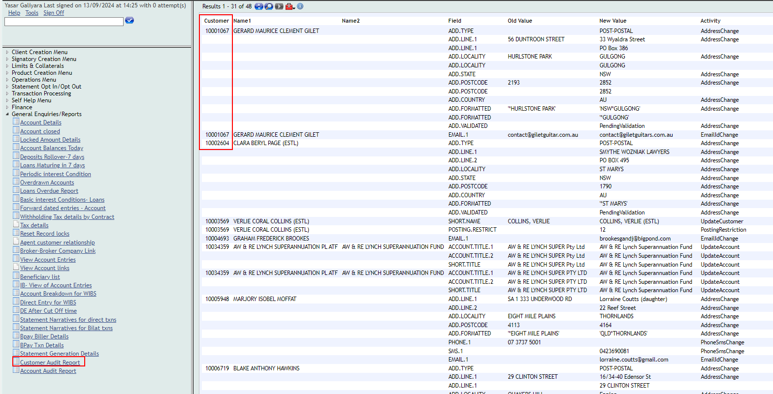

1. Customer name

Show Customer name (Name 1) similar to how it’s shown in Customer Audit Report.

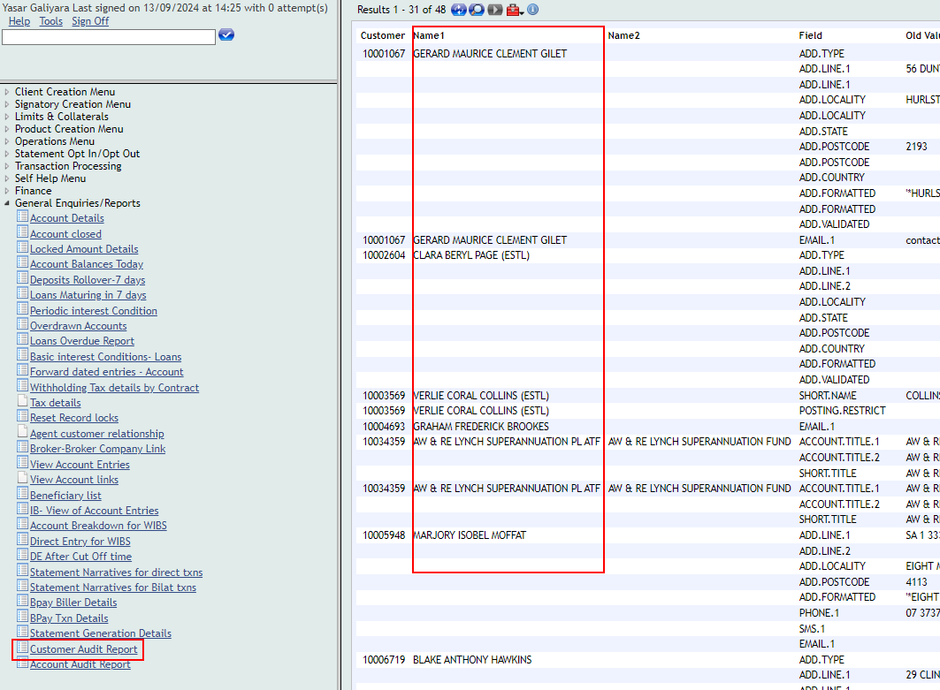

1. Account Title

Account Audit report to show account title from GB Short Title field.

### Changes to existing fields in Account Audit report.

1. Correct account number (should not be the core T24 number) in Account field

Account number to show number from Alternate ID.1 field or the relevant field

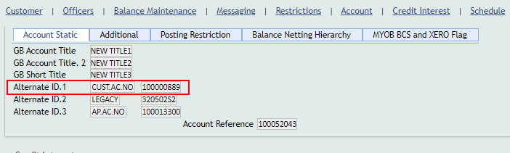

1. To show Product description in Product field

Product field to show Product description of Product or the correct product name from relevant field.

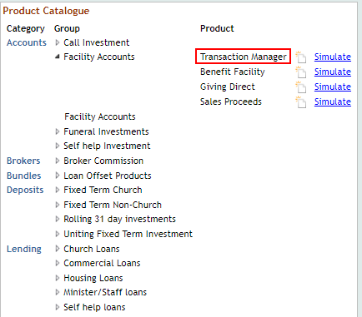

# Detailed Description of Non-Functional Requirements

## Volumes

N.A

## Performance

N.A

## Security

N.A

## Migration

N.A

## Data Requirements

N.A

## GDPR

N.A

## Others (amend heading)

N.A

# Use Cases

1. Business user queries Customer audit report with activity criteria as Address Change, system should list all customers amended in last 7 days by changing or updating any of the address related fields and include the below new fields.
   1. Date of change
   2. Time of change
   3. Inputter detail
   4. Authorizer detail

Existing field:

1. Customer
2. Name 1
3. Name 2
4. Field
5. Old Value
6. New Value
7. Activity
8. Business user queries Account amendment report with activity criteria as Account Title Change, system should list all accounts/deposits/loans amended in last 7 days by updating account title and include the below new fields in the report.
   1. Date of change
   2. Time of change
   3. Inputter detail
   4. Authorizer detail
   5. Customer ID
   6. Customer Name
   7. Account Title

Existing field:

1. Account**:** Account number to show number from Alternate ID.1 field or the relevant field
2. Product: Product field to show Product description of Product or the correct product name from relevant field.
3. Field
4. Old Value
5. New Value
6. Activity